- Go to www.payplus4hisc.com

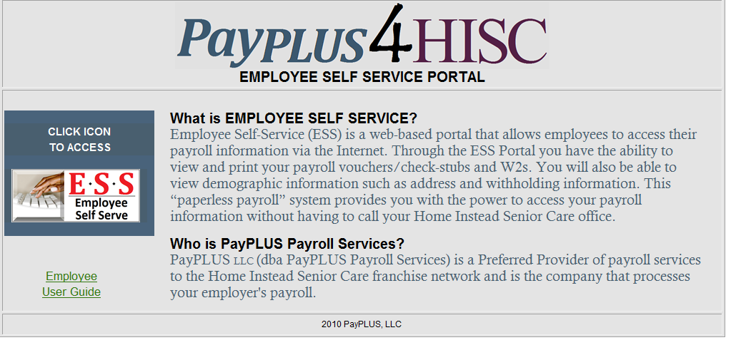

- Click on the ESS Self Service Icon.
You will see the screen below.
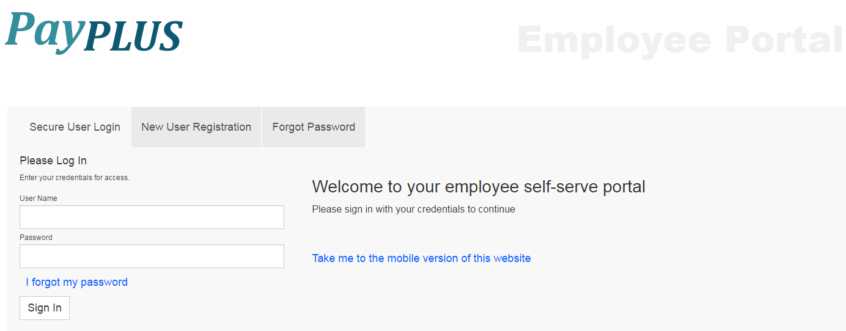

- Enter your user name (first initial of first name, full last name and last 4 digits of SS#) and password (first initial of your first name and first initial of your last name and last 4 digits of SS#). Click Sign In.
You should then see the screen below.

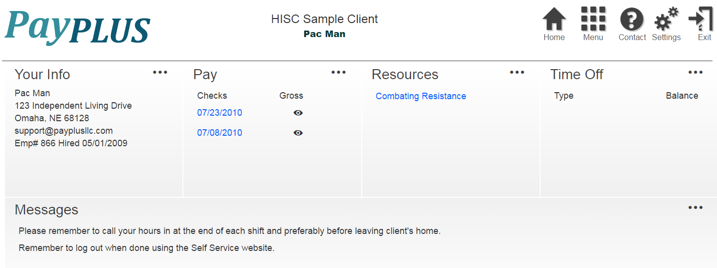

From this area you can access your pay statements by clicking on each of the listed pay dates. You can also access your W2 information (if applicable) by clicking on the tax year listed. Change your password under Settings and access your personal information by clicking Menu.

- To log out, click on the Exit button in the top right-hand corner of the screen.
