How to add employees to ESS in Evolution
- Go to Employee>Employee>Self Serve Tab

- In the Access Level area change all options to Read Only:
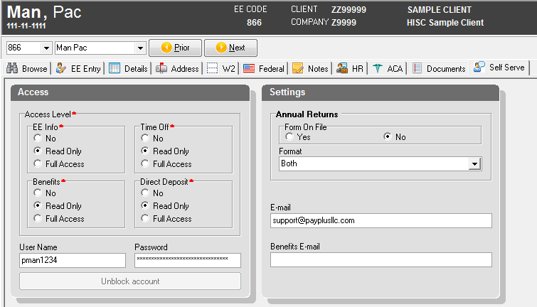
- The username will be set to: first initial of first name, full last name and last four digits of the social security number. The social security number is located at the top of Evolution. (pman1234)

- The password will be set to: first initial of first name, first initial of last name and last four of social security number. (pm1234)

- The e-mail address can be entered if you have it, otherwise it will populate when the employee signs into ESS for the first time.

- The last step is to switch the employee to paperless by clicking on the address tab. In the bottom left, you will need to select NO for the Print Voucher field. This will allow the employee to obtain a copy of the pay stub from the ESS website. PayPLUS will not print a voucher for this employee. Save all changes with the green check and green hamburger.
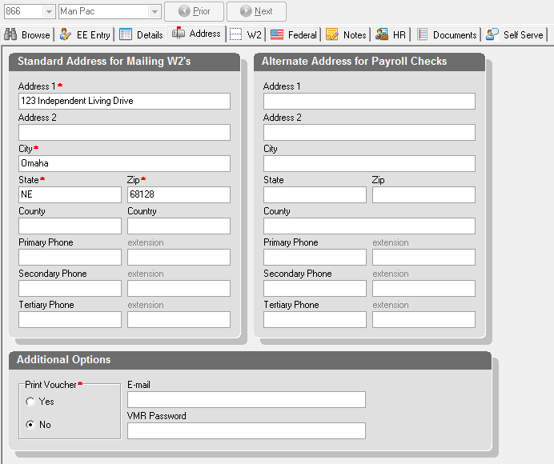

FYI - If an employee tries to log in 3 times unsuccessfully, it will block the account. If the account is blocked, the unblock account button will become bold and become clickable. You will need to click on unblock account and assign a temporary password for the employee to log in again.

